Apply filters to SQL queries

Project description

As a security professional I recently discovered some potential security issues that involve login attempts and employee machines to investigate security issues to help keep the system secure. I used SQL filters to retrieve records from different datasets and investigate the potential security issues.

Retrieve after hours failed login attempts
A potential security incident that occurred after business hours (18:00). All after hours login attempts that failed need to be investigated.

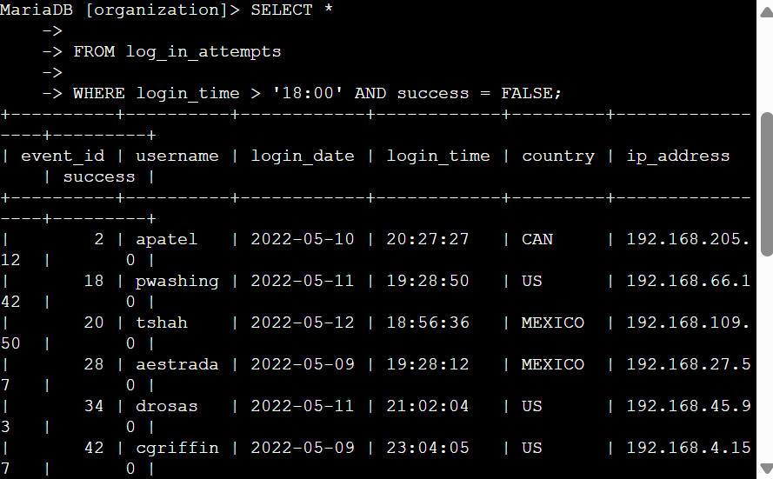

To Retrieve after hours failed login attempts, I use a Linux command prompt with SQL to display the table. In the first line I used {SELECT *} which is responsible for selecting the column in the table and the * means selecting entire columns. The second line I use {FROM} which is used to refer to the table name {log_in_attempt}. The third line I used {WHERE} closed with {AND} which is responsible for indicating a condition for a filter, The first condition is {login_time > '18:00'}, which filters for the login attempts after 18:00. The second condition is {success = FALSE}, which filters for the failed login attempts.

Retrieve login attempts on specific dates
On 2022-05-09 a suspicious event occurred. Any login activity that happened on 2022-05-09 or on the day before needs to be investigated.
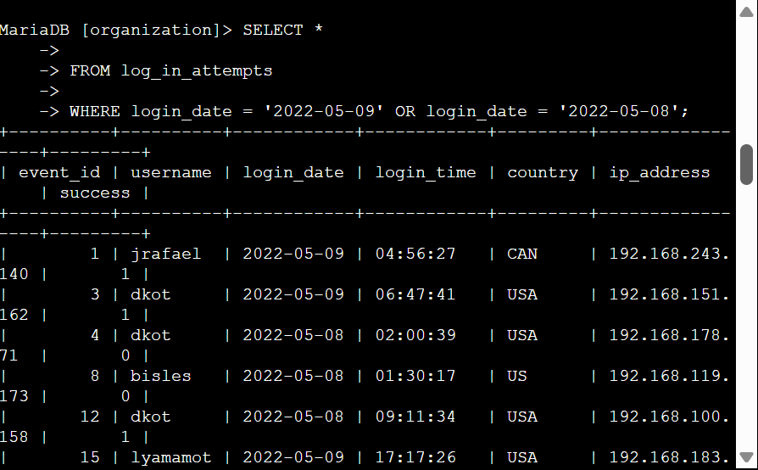

The screenshot displays a table with all log in attempts that occurred on 2022-05-09 or 2022-05-08

In the first and second line I used {SELECT *} and {FROM} to select a column from a specific table named {log_in_attempts}, in the third line I used {WHERE} which is responsible for indicating a condition for a filter, and I close it with {OR} to specify that either conditions can be met, login attempts that occurred on either 2022-05-09 or 2022-05-08. First condition {login_date = '2022-05-09'} the second condition is {login_date = '2022-05-08'}.

Retrieve login attempts outside of Mexico
I noticed that there is an issue with the login attempts that occurred outside of Mexico. These login attempts should be investigated.
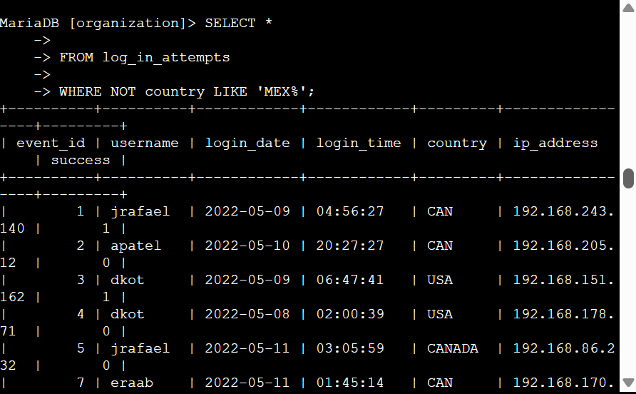

In the first and second line I used {SELECT *} and {FROM} to select a column from the table {log_in_attempt}, in the third line I used {WHERE} which is responsible for indicating a condition for a filter Clouse with {NOT} is used to negate a condition to filter countries other than MEXCICO, the I used {LIKE ‘MEX%’} to search for a pattern in a column.

Retrieve employees in Marketing
I need to update the computers for certain employees in the Marketing department. To perform the updates, I have to get information on which employee machines to update.
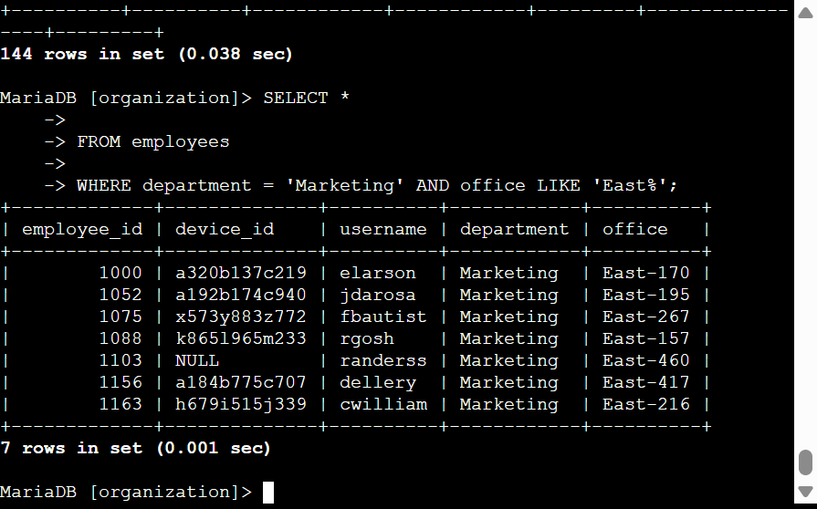

In the first and second line I used {SELECT} and {FROM} to select a column from a new table {employees}, in the third line I used {WHERE} which is responsible for indicating a condition for a filter ,Clouse with {AND} witch specifies that both conditions must be met simultaneously, to filter for employees who work in the Marketing department and in the East building, The first condition is the {department = 'Marketing'} The second condition is the {office LIKE 'East%'} {LIKE} used with where to search for a pattern in a column.

Retrieve employees in Finance or Sales
An update needed for employees’ machines in the Finance and Sales departments. I have to get information on employees only from these two departments.

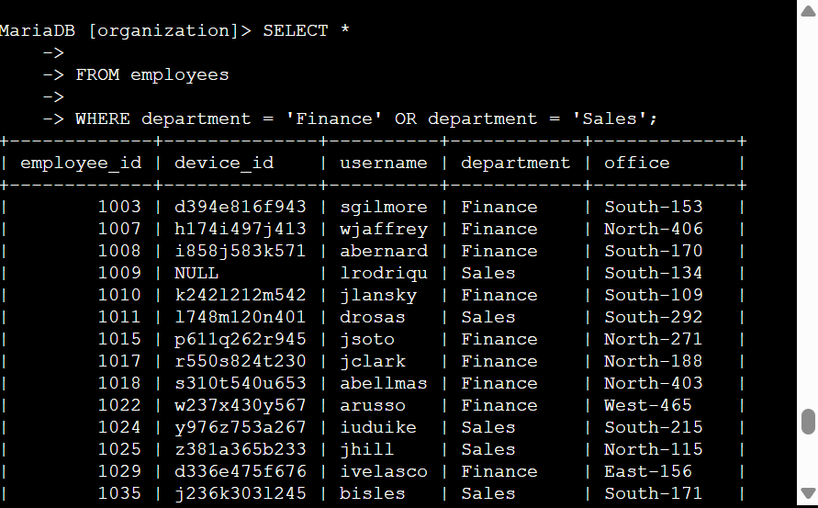

In the first and second line I used {SELECT} and {FROM} to select a column from a specific table, in the third line I used {WHERE} which is responsible for indicating a condition for a filter with Clouse {OR} specifies that either conditions can be met, {LIKE} is used with where to search for a pattern in a column. The first condition is {department = 'Finance'} The second condition is {department = 'Sales'}.

Retrieve all employees not in IT

A security update is needed for employees who are not in the Information Technology department. to make the update, I have to get information on these employees.
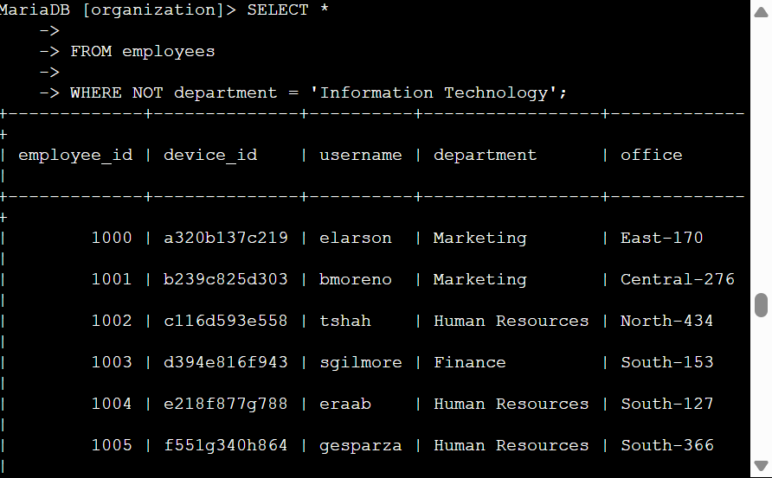

In the first and second line I used {SELECT} and {FROM} to select a column from the employee table, in the third line I used {WHERE} which is responsible for indicating a condition for a filter, clause with {NOT} is used to negate a condition, to filter for employees not in this department.

Summary
To investigate security issues related to login attempts to help keep the system secure. I used filters to SQL queries for different tables, I used {SELECT} {FROM} TO retrieve records from different datasets, also I used {AND} {OR} and {NOT} operators to filter for the specific information needed for each task. I also used {LIKE} and the percentage sign (%) wildcard to filter for patterns.

